KARABUK UNİVERSITY ERASMUS -BLENDED INTENSIVE
“Learning from Paphlagonia, Designing the Future” Project
6-10 May 2024 Hadrianapolis /Safranbolu/Yörük Village/Amasra/Tieos
Project Executives:
Karabük University Başak Cengiz Faculty of Architecture Faculty Members:
Prof. Dr. Aysun ÖZKÖSE, Assoc. Dr. Nermin AGHAYEVA, Assoc.Prof.Dr. Çiğdem BOGENÇ
Workshops are an important starting point for updating design education and making it suitable for the information age; It is very important for the education of contemporary designers in terms of covering short-term, effective, extra-curricular activities and providing many skills and features that are difficult to provide in education.
In this project, in line with these general inferences, to discover the traces of this civilization in the cities in the Western Black Sea Region of Anatolia, called "Paphlagonia" in history (1200 BC), to examine the establishment models of these cities, to make inferences from the detected situations and to examine the current preservation of these cities. It is aimed to observe the problems and to make students dream for sustainability and to produce new design ideas with these dreams.
.
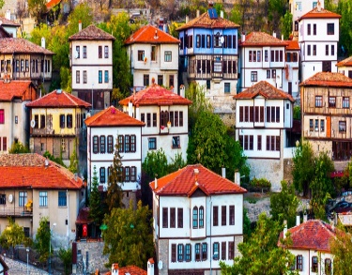
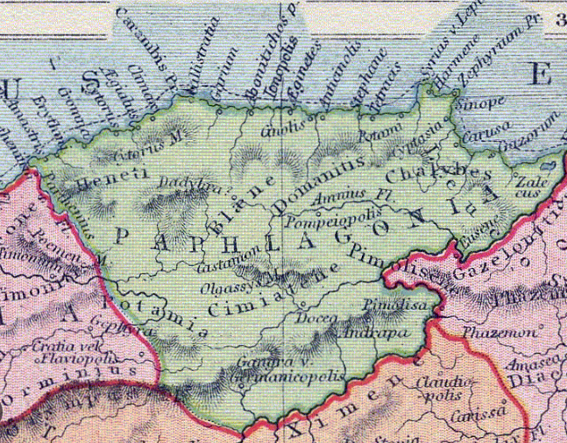
Safranbolu
Paflagonia

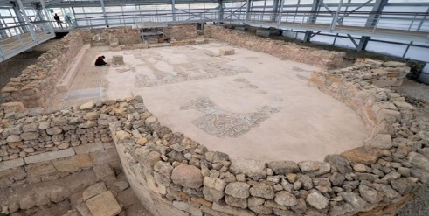
Hadrianapolis

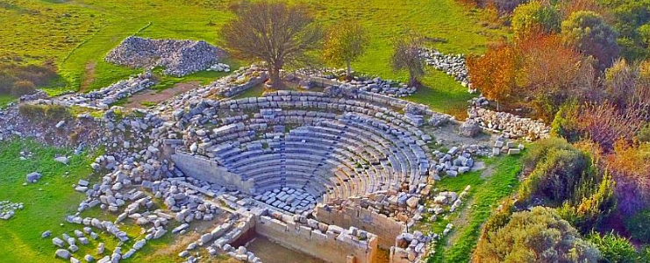
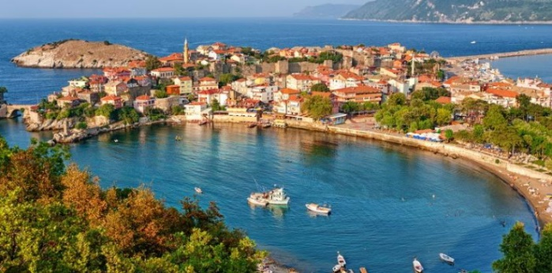
Tieion Antik Kenti
Amasra

SCOPE OF THE PROJECT
The aim is to examine and learn the old settlements of Karabük -Eskipazar/Hadrianapolis, one of the old cities in the region called Paphlagonia in history, and the World Heritage City Safranbolu, Amasra/Amastris, Teos-Filyos/Zonguldak, and to provide the ability to make sustainable, ecological and innovative designs.
“Learning from Paphlagonia, Designing the Future” Project will be held online between 02.04.2024 and 16.04.2024, and face-to-face training activities between 06.05.2024 and 10.05.2024, field trips to examine the areas on-site and workshops in Safranbolu. It covers.
Workshops;
*Sustainable and ecological design
*Accessibility/Mobility
*Innovative Design,
It will be carried out under 3 main themes: working groups will be formed according to the interests and wishes of the participating students. Participating faculty members will provide educational and project consultancy to the students in each study group. At the end of the project, the participating faculty members will be given a document proving that they have taught, and the participating students will be given a course completion certificate worth 3 ECTS. It will be preferred that the number of project participants be between 3-5 people from the same university. All trips within the scope of the study and transportation of the participants from Istanbul to Safranbolu will be covered by Karabük University.

Template program

A. Online Training
1) 02.04.2024- 10:00 pm – 4:00 pm
Basic concepts, Introduction of work areas; Introduction to research, Presentation of general information about the study program

2) 16.04.2024-10:00 pm – 4:00 pm
Presentation of theoretical information and case studies on study subjects by relevant faculty members
Lecturers :
Prof. Dr. Aysun ÖZKÖSE, Assoc. Prof. Dr. Narmin AGHAYEVA, Assoc. Prof. Dr. Çiğdem BOGENÇ and Other Country Participants

B. Face to Face Training

Day 1- 06.05.2024
Project opening and training presentations and field trips
Location: Safranbolu Academy of Science and Arts-Old Hospital Building
10:00- 12:30 Project opening and training presentations
Lecturers
* (Prof. Dr. Aysun ÖZKÖSE) and other participating country trainers
12:30-13:30 Lunch (will be covered by KBU)
13:30-17:00 On-site examination of project areas in the World Heritage city Safranbolu
*Hıdırlık Hill
*Safranbolu Historical Bazaar
*Cinci Han and Surroundings
*Old Government House Urban History Museum and Clock Towers Museum
*District Governors Museum House
*Old Tannery Area

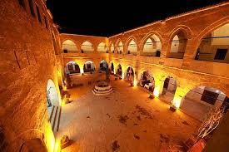
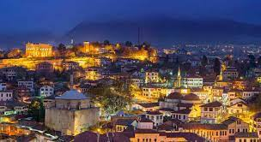
Safranbolu Cinci Han
Safranbolu Historical Bazaar

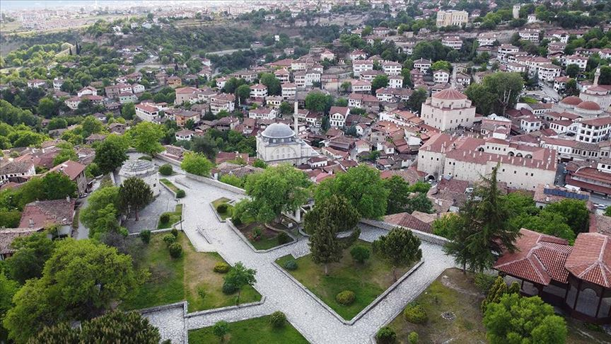
Hıdırlık Hill
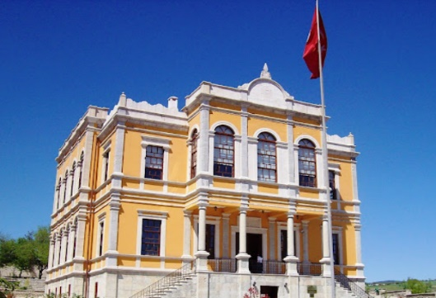
District Governors Museum House

17:00- 19:00 Group Studies
19.00- Dinner
Day 2 07.05.2024
Project Field Trips (Continued)
09:00 13:00
*Visiting Eskipazar Hadrianapolis Ancient City
*Bağlar Region and İncekaya Aqueduct in Safranbolu, UNESCO World Heritage List
*Yörük Village
12.30-13.30 Local lunch in Yörük Village.

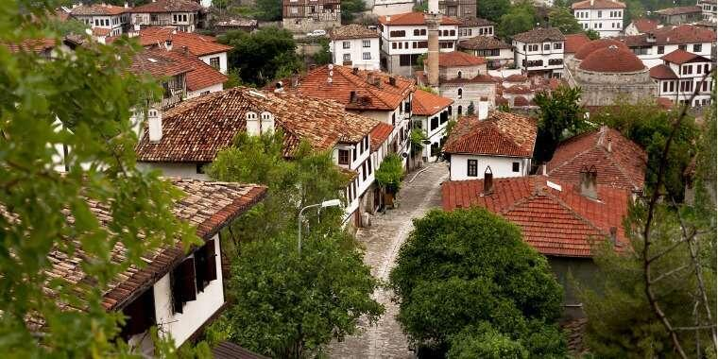
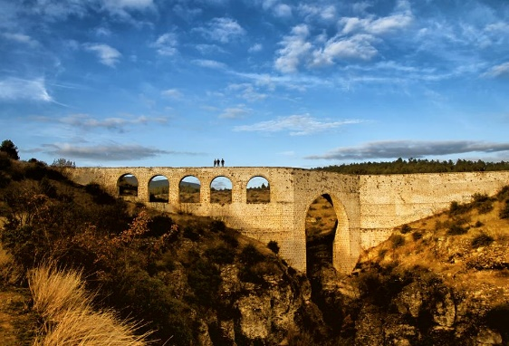
Yörük Village
İncekaya Aqueduct

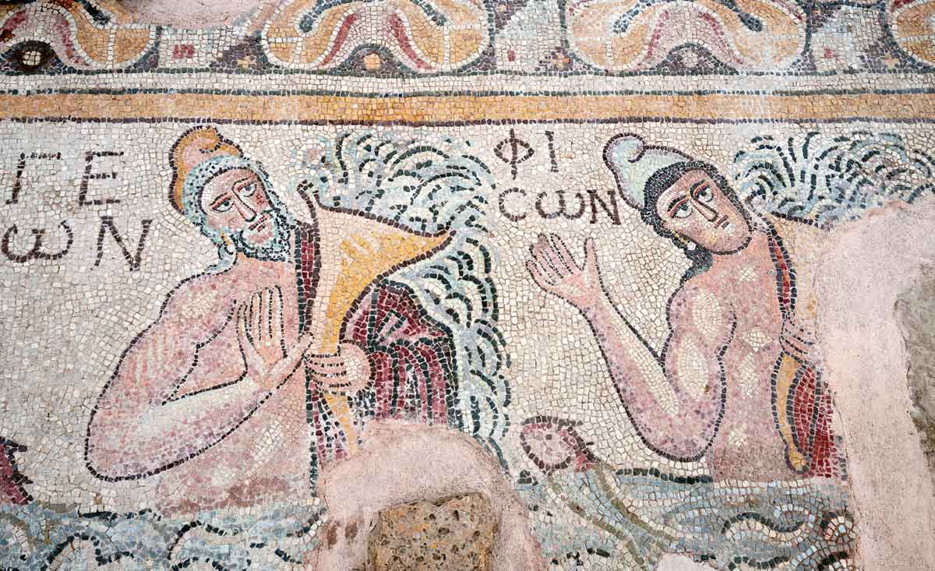
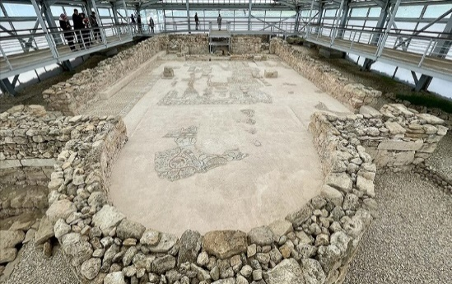
Hadrianapolis Ancient City

Hadrianapolis Ancient City

14:00-18:00 Safranbolu. Fuat Sezgin Safranbolu Science and Art Academy Group
Continuation of Workshop activities, Presentations, evaluations
18:00 Free Time
3.Day 08.08.2024 Project Field Trips (Continued)Filyos, Amasra
08:30-10:30 Safranbolu Zonguldak Teos Ancient City and Filyos Trip
10:30-12:30 On-site inspections of the Ancient City of Teos
12:30-13:30 Lunch
13:30-15:30 Filyos-Amasra-Amastris Trip
15:30 -18:30 Amastris (Amasra Castle, Amasra Museum, Old Bedesten)
18:30-20.30 Amasra Dinner (Probably Local Fresh Fish)
20:30-22:00 Journey to Safranbolu
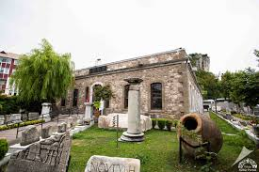
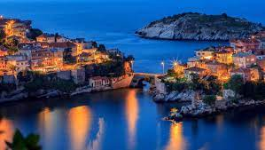
Amasra Museum
Amasra
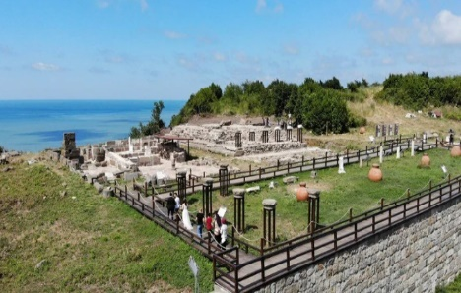
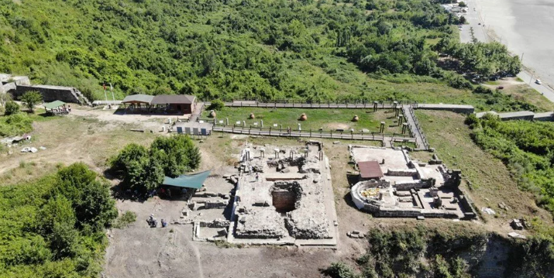
Ancient City of Teos
Day 4 09.05.2024 Continuation of the workshop activities of the groups and Project Evaluations
09:00 -12:30 Safranbolu Prof. Dr. Fuat Sezgin Safranbolu Science and Art Academy Group
Continuation of Workshop activities
12:30-13:30 Lunch (to be covered by KBU)
13:00-16:30 Finalization and presentation of group workshops
16:30-17.00 Presentation of Participation Certificates
19.00- Dinner by Karabuk University

Day 5 10.05.2024
11.00 Safranbolu Istanbul Journey (Provided by KBU)

